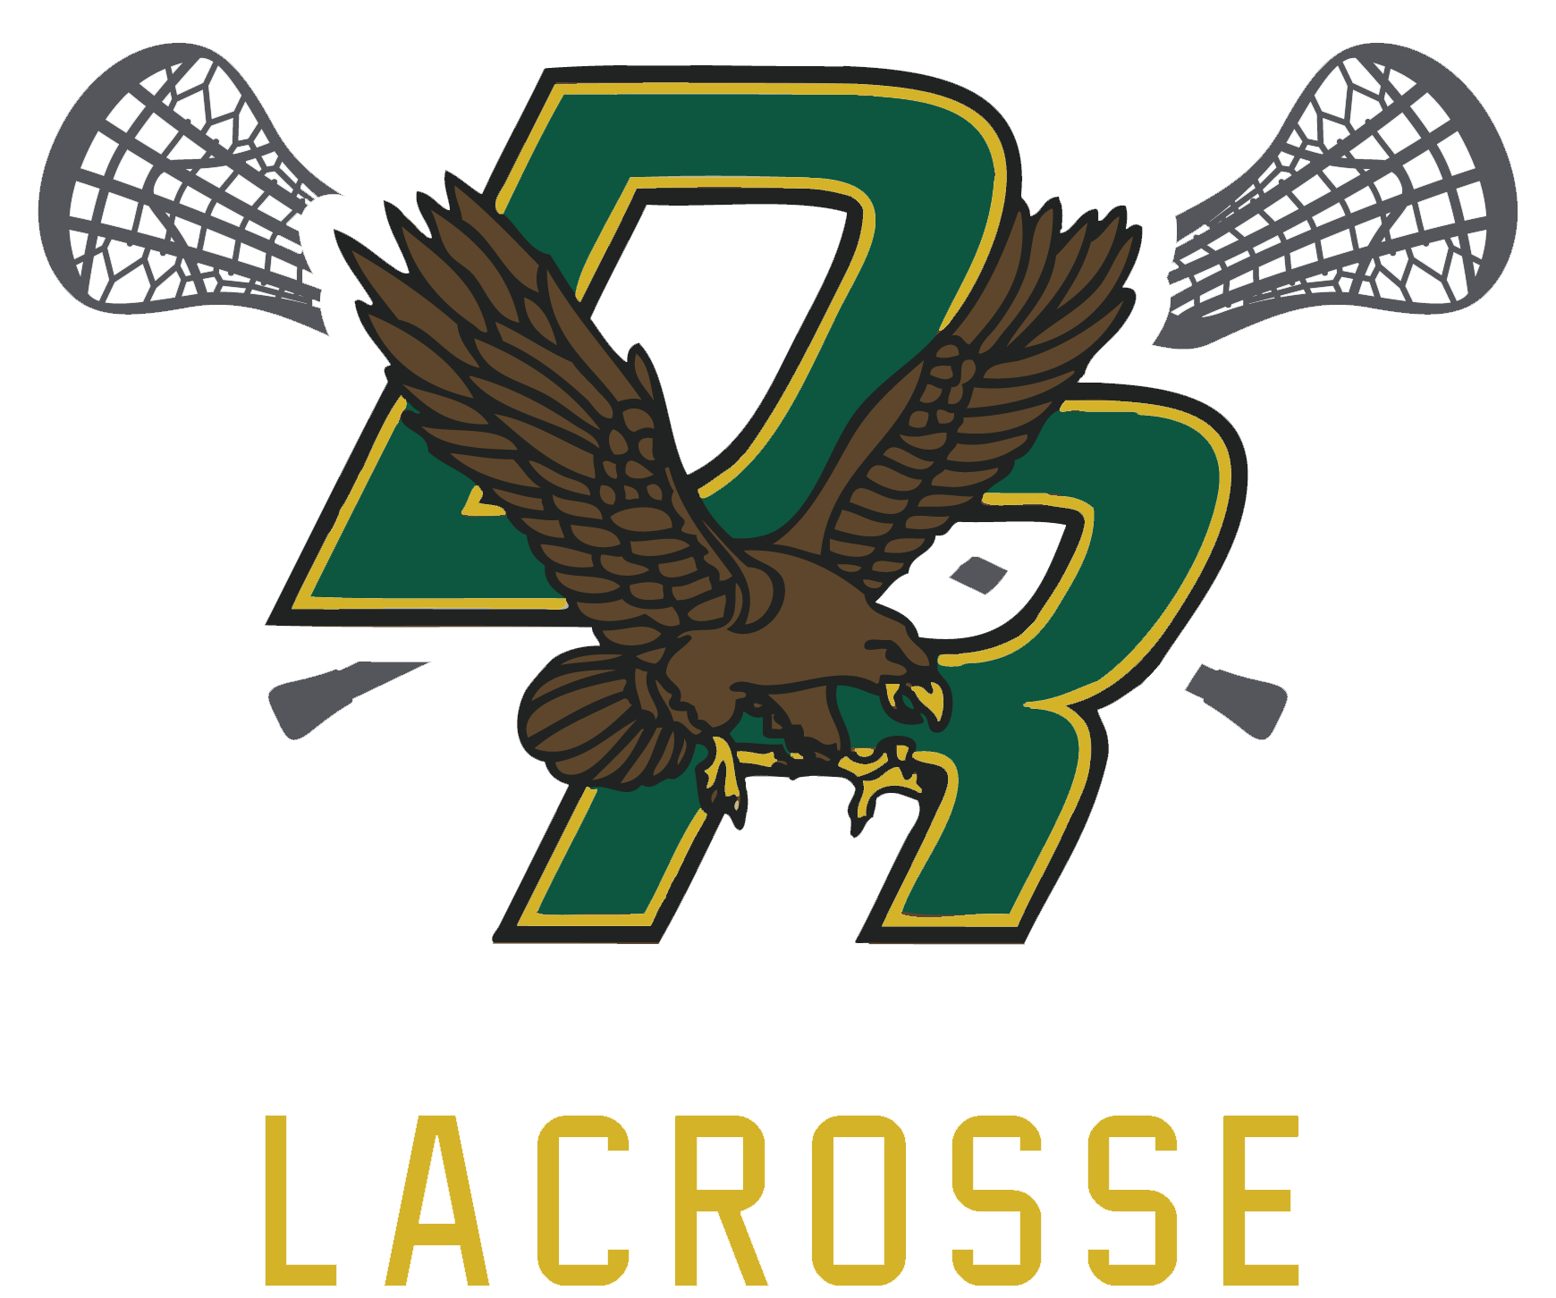

3/12/2024 7 PM- D2S

- Financials
- Update from Chip- currently at $38-39k
- Currently $50 for insurance, full cost $260- we will reimburse $160 (total $1760) at first game
  - 6 girls
  - 5-6 boys
- Ref payments/coordinating-
- Registration at 114 currently, couple more coming in (next year populate the teams prior to opening registration so that kids are registered into the right team, open earlier next year)

- Season Updates
  - Plan for next week
  - Coach Schedule
  - Game schedule- pending
  - Sticks and goggles- for new players
  - Home Game Concessions - Michelle Carpenter to organize; need to buy food before 4/7
  - Pop up store-michelle
    - Youth Grey Hoodie- 2 Ymed- $5
    - Youth Green Hoodie- 1 YL $5
    - Youth Grey Tee- 2 YXL $5
    - Adult Blue Long sleeve- 5 Med $5
    - Adult Grey Hoodie- 6 small, 4 med, 3XL
    - Green T shirt- 4 Ymed, 2 YL, 2 adult small, 1 adult med, 5 adult XL
    - Pink Breast Cancer t shirt- 2 YMed, 2 YL, 2 Adult Small $5
    - 3 random extra youth tees $5
    - 15 mouth guards (don’t sell)
    - Pura vida bracelets $5

- Fundraisers
- Savers- ends 3/22, delivery to Fall River 3/22, email reminder
- Self Defense Class w Kayla? Tues or Thurs @ Town Hall?
- Chicken BBQ 6/30
- Calendar raffle- scrap the calendar; use donations for raffle basket

Next meeting- April 9, 2024

