In-town Referee Pay Rate per Game.

2nd Grade - $10
3rd Grade - $10

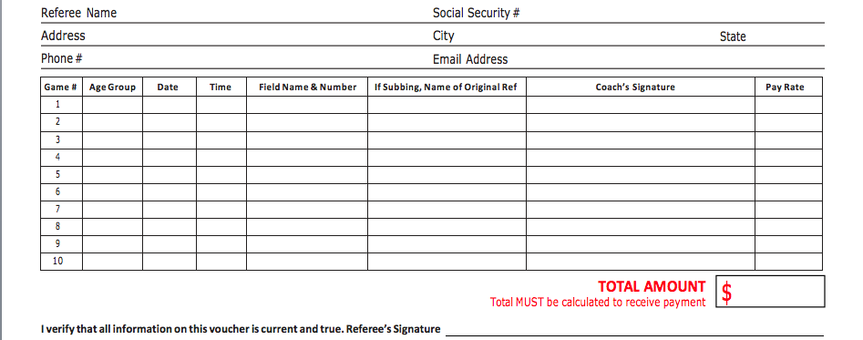

IMPORTANT NOTES TO ALL REFEREES – PLEASE REVIEW
- Referees must report all incidents immediately to Roxy Lee-Stewart by calling 857-265-9968 or emailing rlee-stewart@globalpremiersoccer.com
- Deadline to submit Fall 2016 pay sheet is June 1,2016, the pay sheet will not be processed and paid if it does not match the master schedule.
- Referees are not paid for games that are cancelled by WUSC. Please go to the WUSC website www.wellesleysoccer.org and check the home page for field status.
- Questions concerning WUSC payment issues should be emailed to WUSC at rlee-stewart@globalpremiersoccer.com.
- Any questions should be sent directly to rlee-stewart@globalpremiersoccer.com.

Make a copy for your records and mail it to: Chris Howard, 1133 Madison Place, Southborough, Massachusetts,01772.
Scanned pay sheets can be sent to: rlee-stewart@globalpremiersoccer.com , be sure to write WUSC Referee pay in the Subject Line
In-town Referee Pay Sheet 2016
ONLY FOR 2nd and 3rd Grade IN-TOWN GAMES
For all other BAYS games U9-U14, you must submit game reports to BAYS via BAYS website in order to get paid.

